DOCUMENT 04 — VDS: Visionary Design System
Visionary Internal · v1.0 · Cognitive Companion Interface.

The interface is a companion, not a dashboard. Calm, specific, human. No humanoid
avatars, no generic praise UI, no decorative AI orbs-as-mascot. Dark mode secondary.

1. Tokens
- Color: Deep Teal #0F766E (action) · Mint #10B981 (AGI/live signal) · Ink #111827 ·
Paper #FFFFFF/#F7F8F7 · semantic amber (needs-attention) / red (gap) used sparingly.
- Type: Inter (Latin) + Noto Sans per-script (Indic). Indic line-height 1.5, min
weight 400. Display tier for emotional statements; strong size/weight contrast.
- Space: 8pt grid; generous section rhythm; one idea per screen.
- Radius/elevation: 12–26px surfaces; soft shadows; no blanket glassmorphism.
- Targets: 44px touch; WCAG 2.1 AA; focus rings; reduced-motion respected.

2. Signature components

Component | Purpose | Rule
Mastery Ring | shows P(mastered) as a ring + number | never color-alone; always numeric
3D Canvas Container | hosts [SCENE] | 2D SVG fallback; user-driven, no auto-spin
Socratic Hint Button | reveals a hint, not the answer | never reveals solution
"Things I Remember" card | the moat, made visible | weekly, TRUE observations only
AGI orb / waveform | the AGI's presence (listening/thinking/speaking) | mint; pulses only when active

3. Motion doctrine
- Streaming text in 2–3 word chunks with a blinking block cursor (feels like thinking).
- Motion only to explain / focus / show transformation. 150–400ms ease.
- No scroll-hijack; user always in control.

4. Component tree
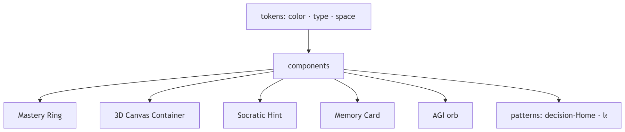

OKF
KF1: every screen passes WCAG AA + 44px. KF2: Indic renders at lh 1.5 with no clipping.
KF3: memory card shows only TRUE observations. KF4: 3D always has a 2D fallback.
KF5: reduced-motion removes non-essential animation without hiding state.

